**[01] Professional Discussion based on Portfolio of Evidence**

**[01] Management, leadership and effective communication**

[[K2.7 & B1.7]](https://live.onefile.co.uk/standards/form.aspx?StandardID=67843&UnitID=RESSLAO_01#01) (Distinction): Can describe the leadership styles that exist in their workplace and can compare and contrast these with theory

Leadership plays a vital role in the industry; it shows the responsibility and the trust of a person in the project towards their organization.

This course has given me a new ability to adapt a new communication style, because different communication styles are the most frequently cited cause of poor communication. Every employee’s motivation is different, so knowing how to tailor your communication is essential to influencing others and reaching organisational goals.

The KSB classes helped me to become an essential leader, as one of the feature I have learned as when I need to talk and more importantly when I need to listen. So I can ask my colleagues opinions, ideas and feedback. And at the same time they do share actively engage in the conversation, pose questions, invite them to elaborate and take notes.

Is has helped me to be more transparent more like a senior manager by speaking openly about the company’s goals, opportunities and challenges.

It has helped me to built trust amongst the team and foster an environment where employees feel empowered to share their ideas and collaborate.

My thoughts are strategic initiative, clear about what I want to see achieved by the end of each milestone.

I always use TED which stands for

* "Tell me more."
* "Explain what you mean."
* "Define that term or concept for me."

I always ask feedback on me and try to implement the changes which I need to do it else I will be losing the faith on my ability to follow through.

It's likely there will be comments I can't immediately act and I am always transparent about that.

As per my leadership principles I have conducted multiple technical session not only with my team but also for the entire region.

After taking classes for two month, I got an opportunity to conduct session globally and got a side position of an Instructor in my organization. Received Go Beyond from the “*Head of Visa University*”

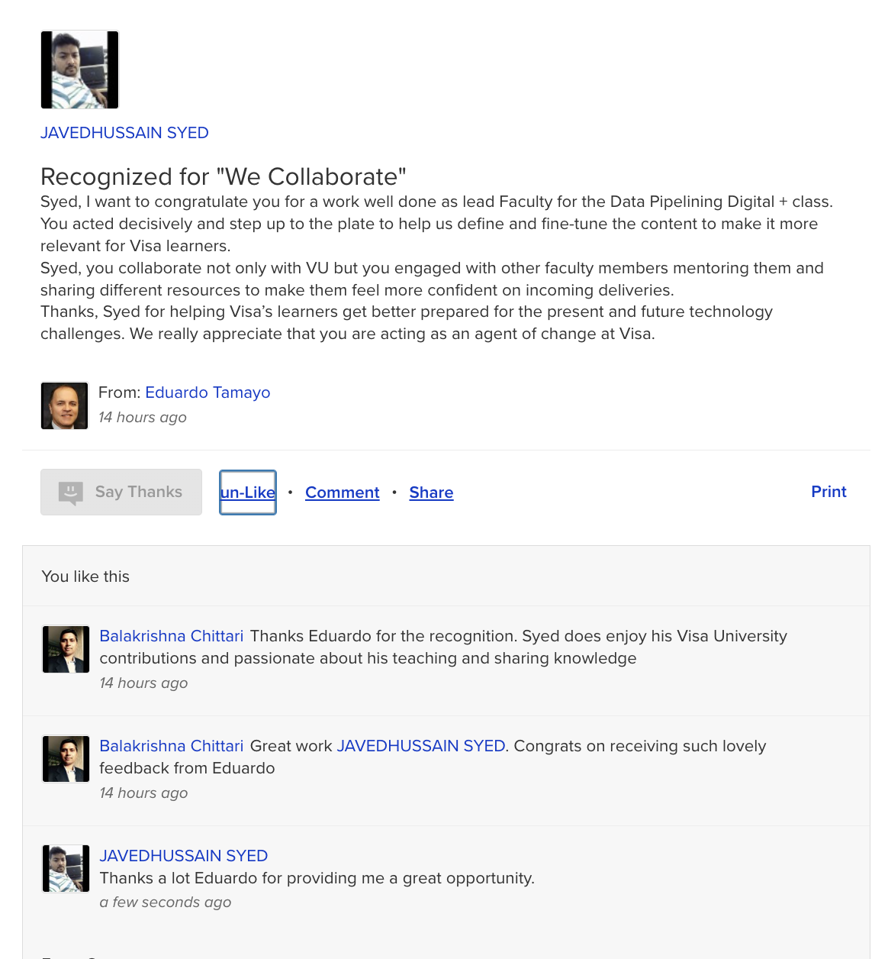

[[K2.1 & B1.1]](https://live.onefile.co.uk/standards/form.aspx?StandardID=67848&UnitID=RESSLAO_UOE_01_#01) (Pass): Describes where their role has contributed to the successful achievement of an organisational objective and provides examples of when they have communicated effectively with a wide range of senior leaders across different departments

As per my daily work I work as a Data Engineer and interacts with Data Scientist team to gather the requirements and sometimes we get involved in the clients’ meetings where we interact with senior leaders who runs the business.

Sometimes it very difficult to keep tech stack conversation with the leadership team as they don’t have much knowledge on the technology side, so to run the smoothly conversation we need to explain everything in a business way.

One of the examples I want to discuss about Barclay Reward Program where we need to identify the cardholders transactions based on that we can come up with the loyalty for each card holder, I cannot share more information as it against my organisation principles.

In that project we have interacted with multiple senior leaders of the Europe region and worked closely for almost two month, we use to have a call every alternative day for the status. We worked closely with the Data Scientist as they were doing the analysis and our job is to provide them a clean and normalised data.

I have interacted with multiple people in the team and across the team and received a good feedback from them.

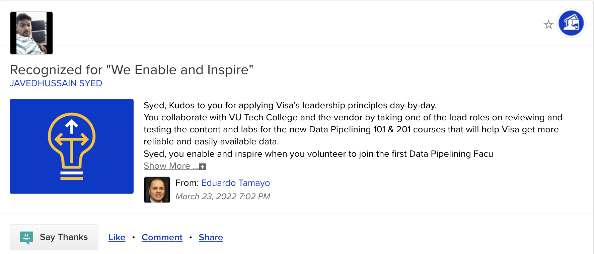

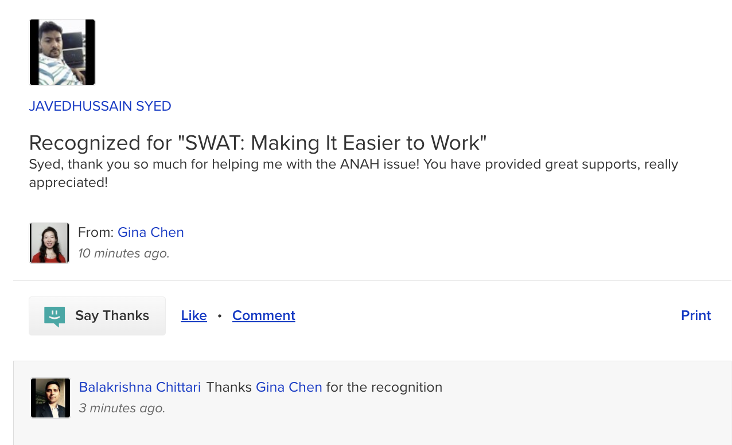

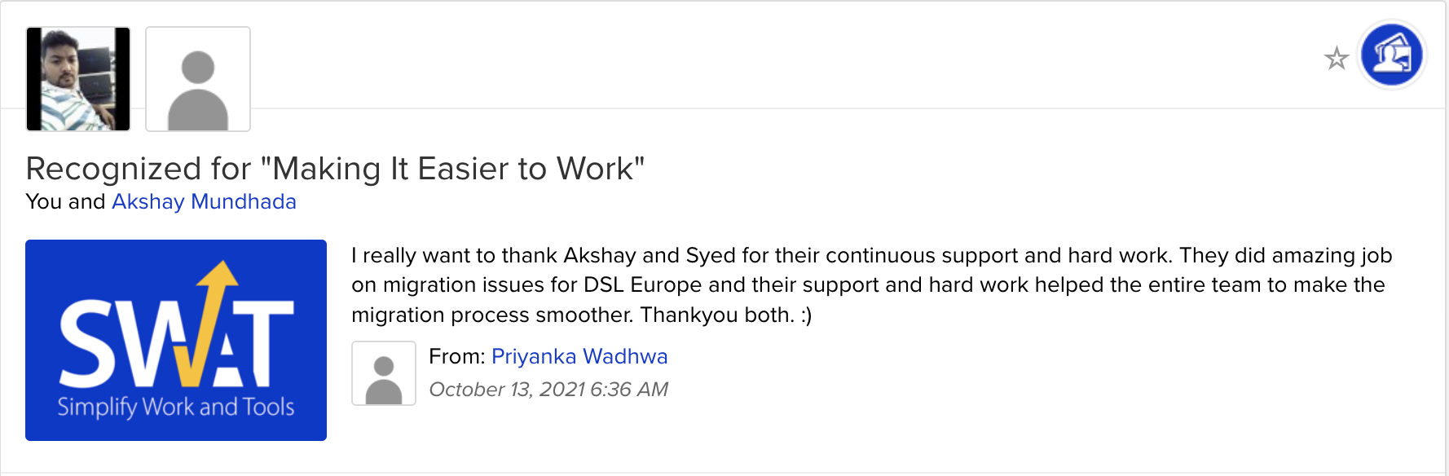

[[K2.3 & B1.3]](https://live.onefile.co.uk/standards/form.aspx?StandardID=67848&UnitID=RESSLAO_UOE_01_#01) (Pass): Describes examples of when they have provided leadership within a team of multi discipline specialists at different levels across the organisation, ensuring a shared vision and commitment to success

As part of my developer role I have set some standards and the operational flow, as I have seen lot of Data Scientist creates the Models and there are lack of terms are missing, listed below

1. Documentation
2. Collaboration with each other about their work
3. Source Code repository
4. Teams communication
5. Knowledge sharing
6. Automation

I took some of the action from last 6 months and came up with a new framework and some standards and discussed this idea with the Senior Manager and he really liked my idea.

**Documentation:**Everyone is working but what no one know, only the respective manager knows about their work, if some person leaves the organisation during knowledge transfer was bit difficult process because of lack of documentation.

Me and my senior manager discussed these with the Leadership team and came up with the solution to go with *wiki*, we got a license and I took some of the sessions on the documentation and we have seen the results that multiple people started documenting about their project before they start the design and development.

**Collaboration:**After joining Europe team I have observed people come and go, they do their work and simple leave, they never interact much with other team members or share anything, to improve the collaboration I have discussed this point with my Senior Manager and asked him to conduct some orientation program or outing so people will get close to each other, and it got worked.   
I was a part of mentoring the Hackathon program.  
  


**Source Code repository:**As I have observed multiple Data Scientist writing the code in the Jupyter notebooks but never pushing the code into any repository due to lack of knowledge, we cameup with the Github license and asked everyone to push their code into Git. I have conducted 3 sessions on Git so that everyone is aware on the technology. We got some responses to push code into *sharepoint* then we have changed their mindset to think as a developer.

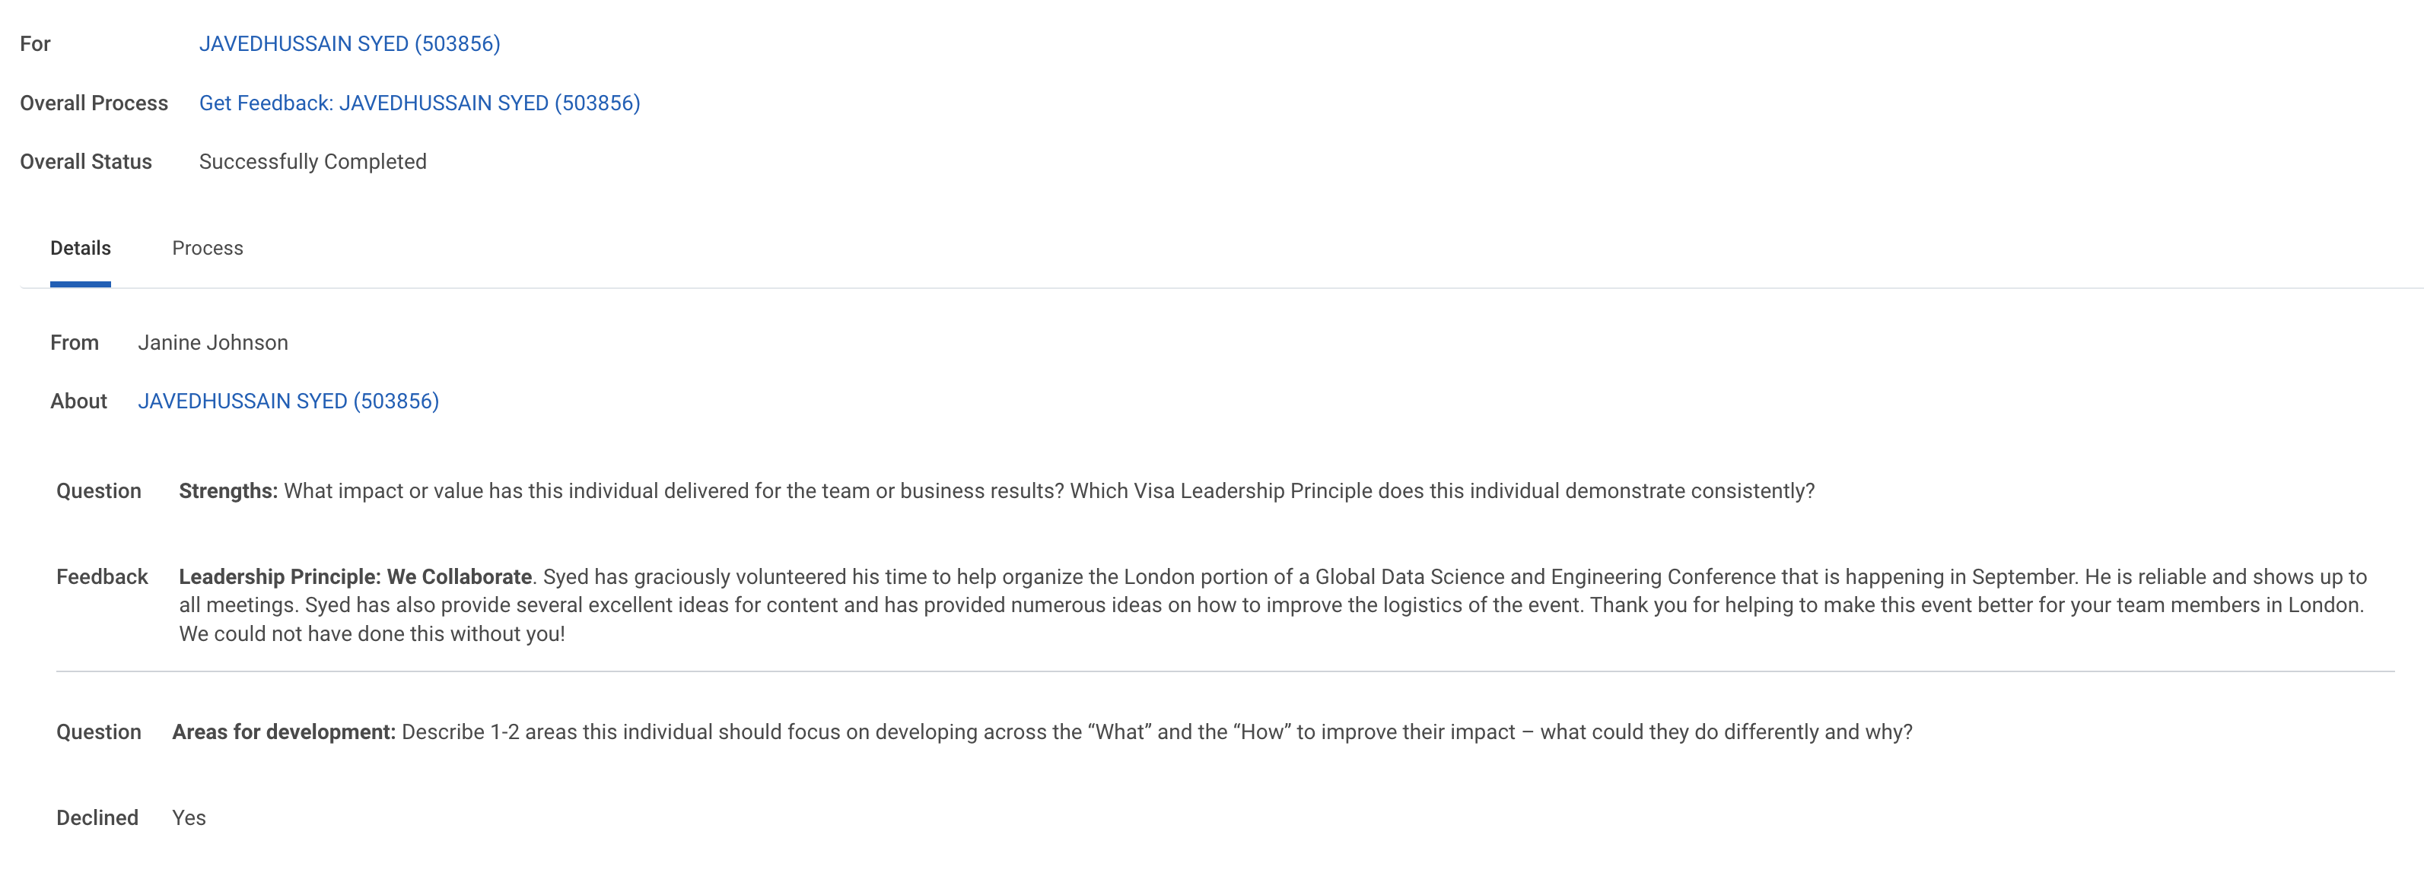

**Teams Communication:**We have created a Microsoft Teams channel to discuss any technical issue, whoever having any issues will post that question in the channel and anyone from the team will respond with an answer.

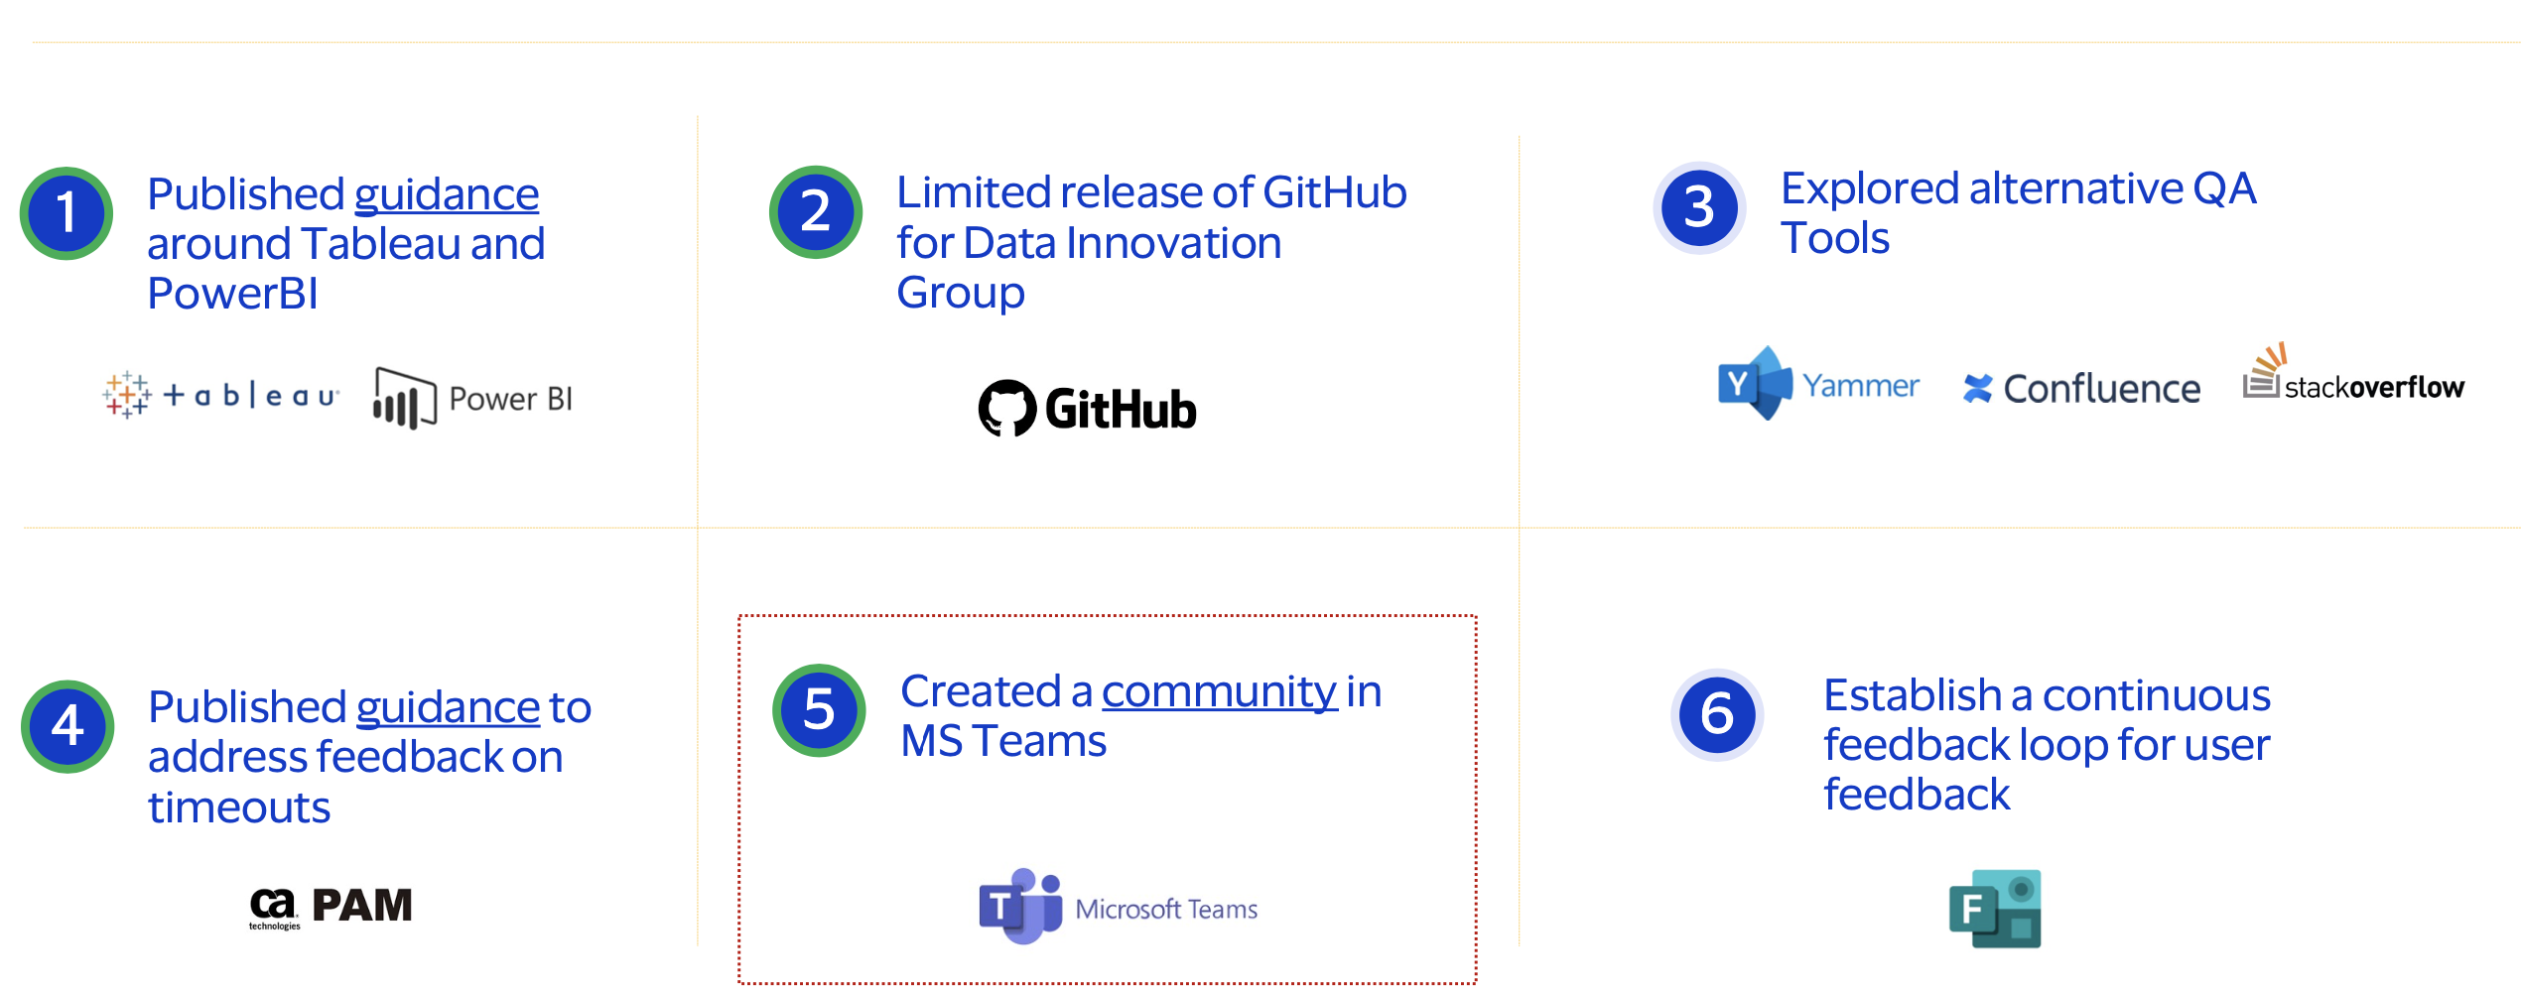

**Knowledge Sharing:**I have introduced a *Learn & Lunch* session, monthly once we will have a meeting, anyone person from the team will discuss about his achievement about the project and will share technical knowledge behind it, so that the project can be reusable.

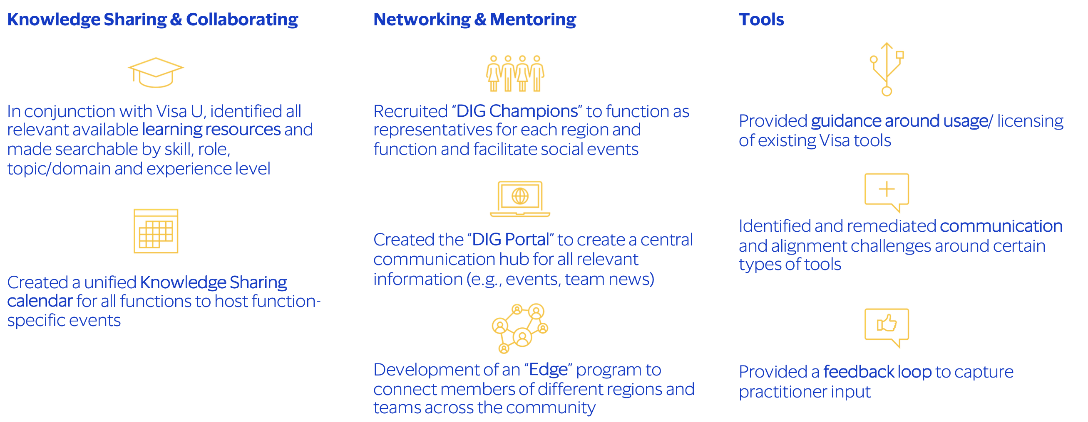

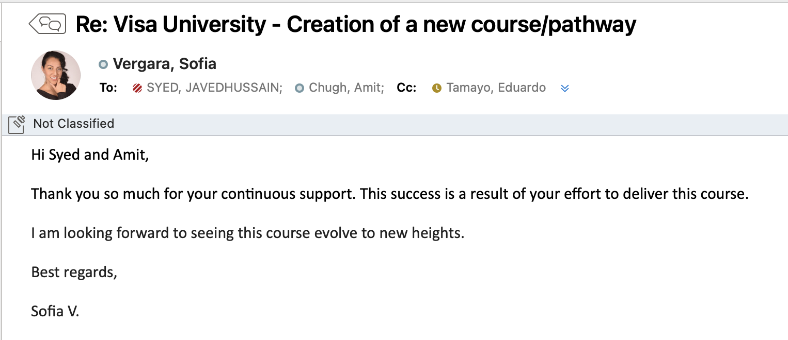

**Automation:**As part of CI/CD pipeline I have helped multiple Data Scientist to automate their models using Airflow, shared knowledge regarding the tech stack and today we have almost 65 jobs running on an automation. We do have a Global Engineering team sitting in Foster City, I use to interact with them every week to know what’s new is going on the technology side.

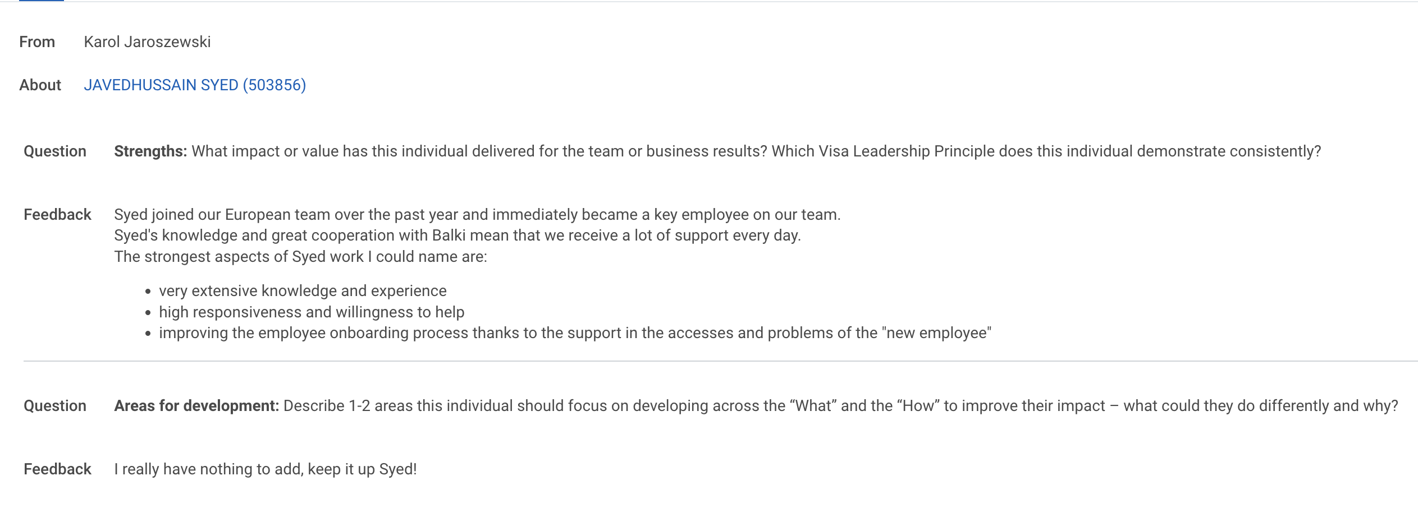

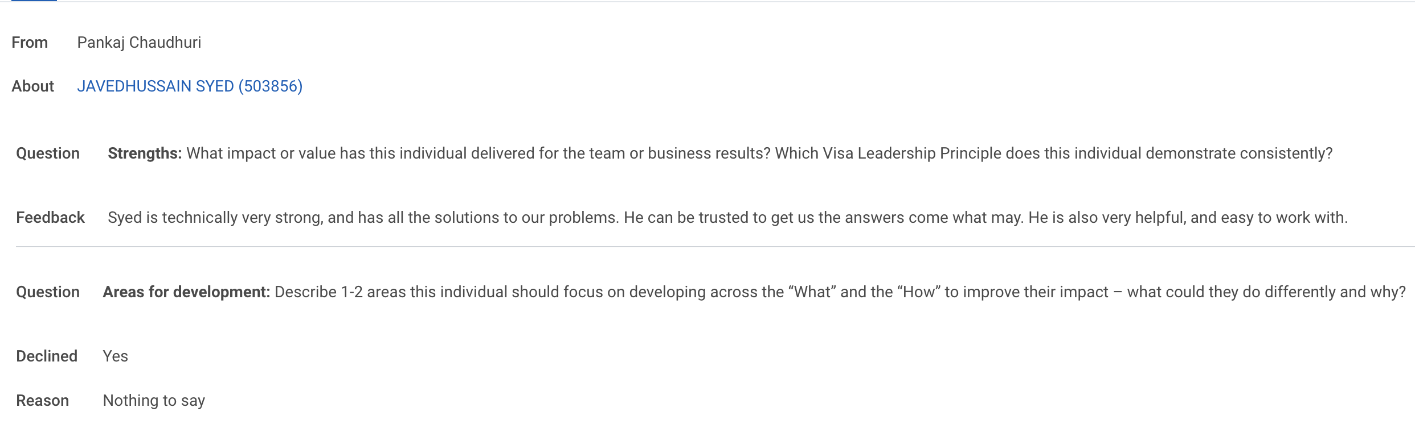

[[K2.5 & B1.5]](https://live.onefile.co.uk/standards/form.aspx?StandardID=67848&UnitID=RESSLAO_UOE_01_#01) (Pass): Describes the employer’s organisational structure and where their own role fits

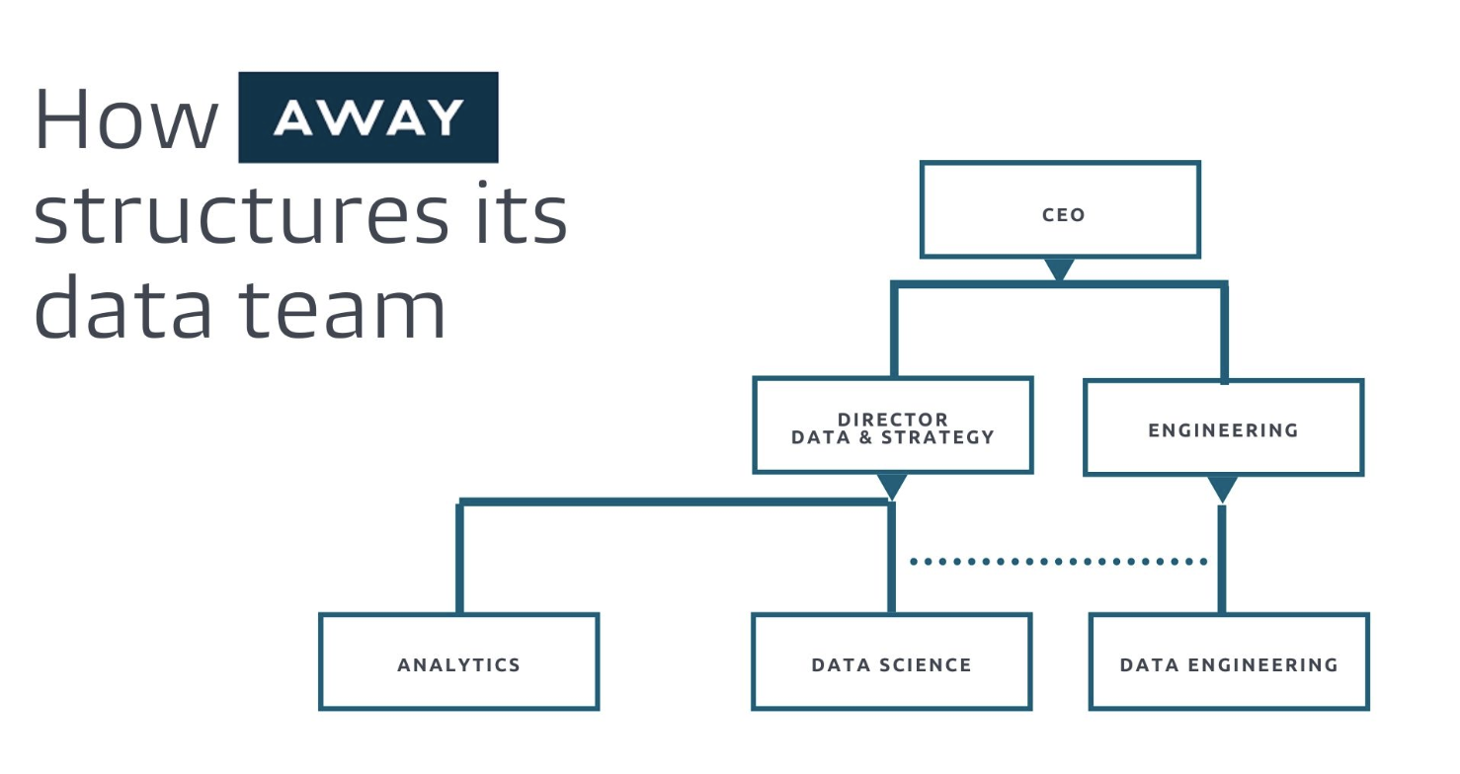

As part of the Data Engineering, I report to my manager, and Manager reports to Senior Manager.

Senior Manager handles multiple teams, and he reports to VP, VP is the head of a Europe Region.

VP reports to SVP and finally SVP reports to EVP 🡪 President 🡪 CEO.

Please find my organization chart below

